**Oatmeal-Cookie Recipe**

..............................................................

**Ingridients:**

1. Oatmeal (220g)
2. Dinkel Vollkorn dough (150g)
3. Dinkelhablweissmehl (150g)
4. Sugar (180g)
5. Butter (250g)
6. Raisins (50g)
7. Baking powder (1 tsp.)
8. Egg (1)

..............................................................

**Instructions:**

1. Grind the oatmeal into powder. You can use a coffee grinder for that.

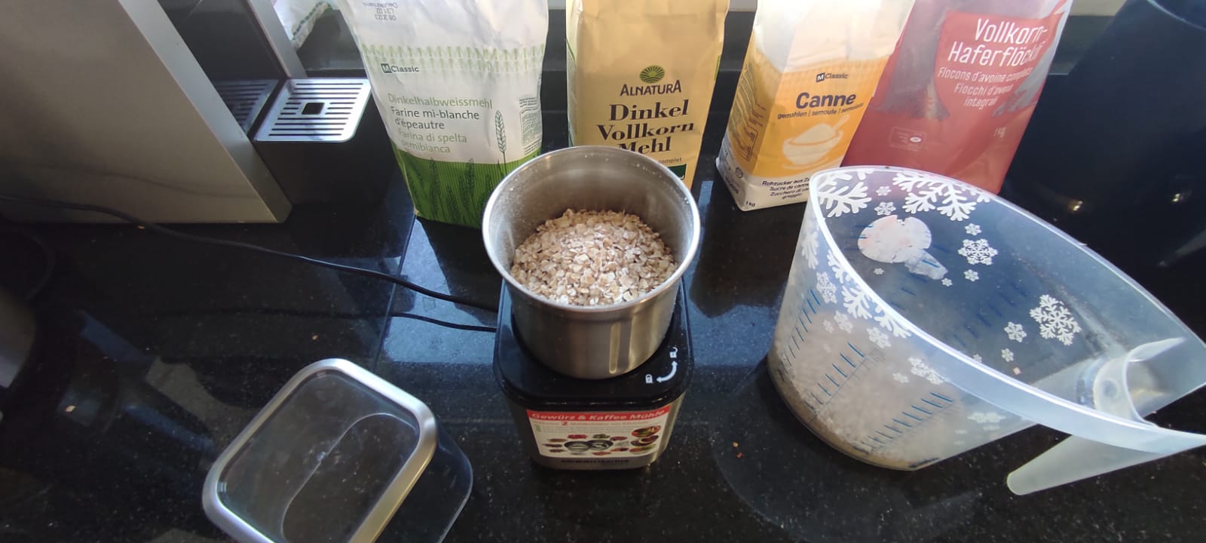

1. Mix all ingridients together.

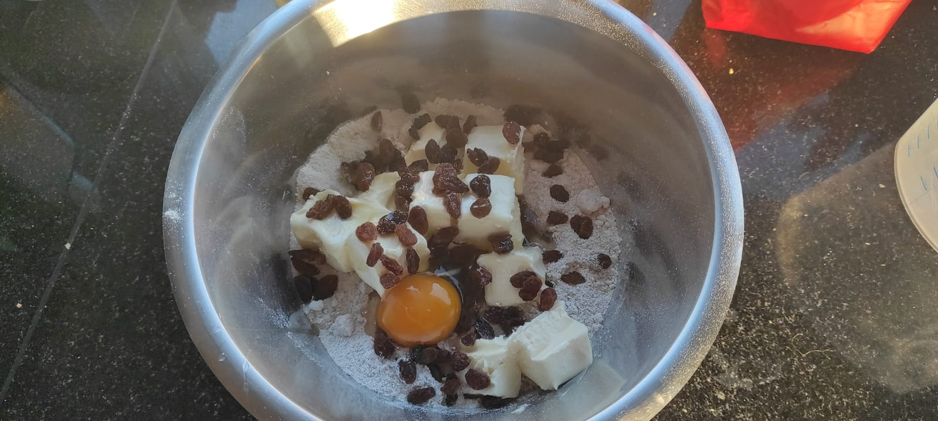

As the end result you must get something like this. If the dough appears to be too dry, add 3 tsp. of cold water.

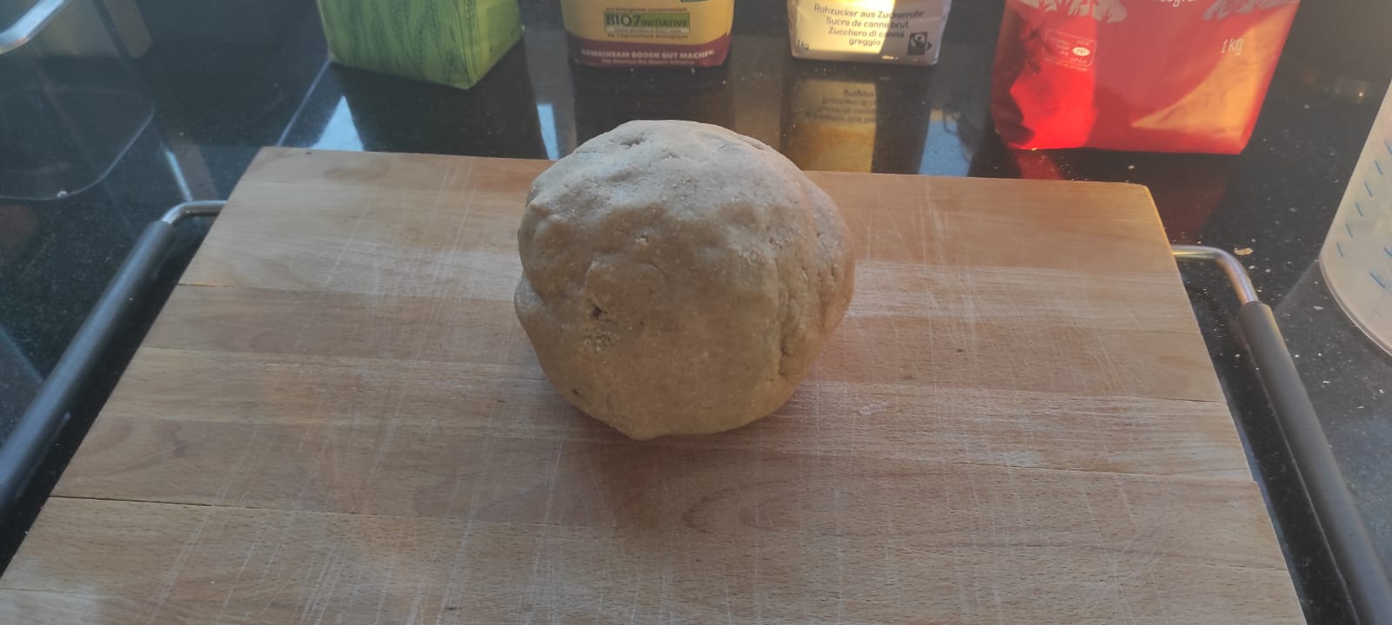

1. Roll the dough into a thin sheet.

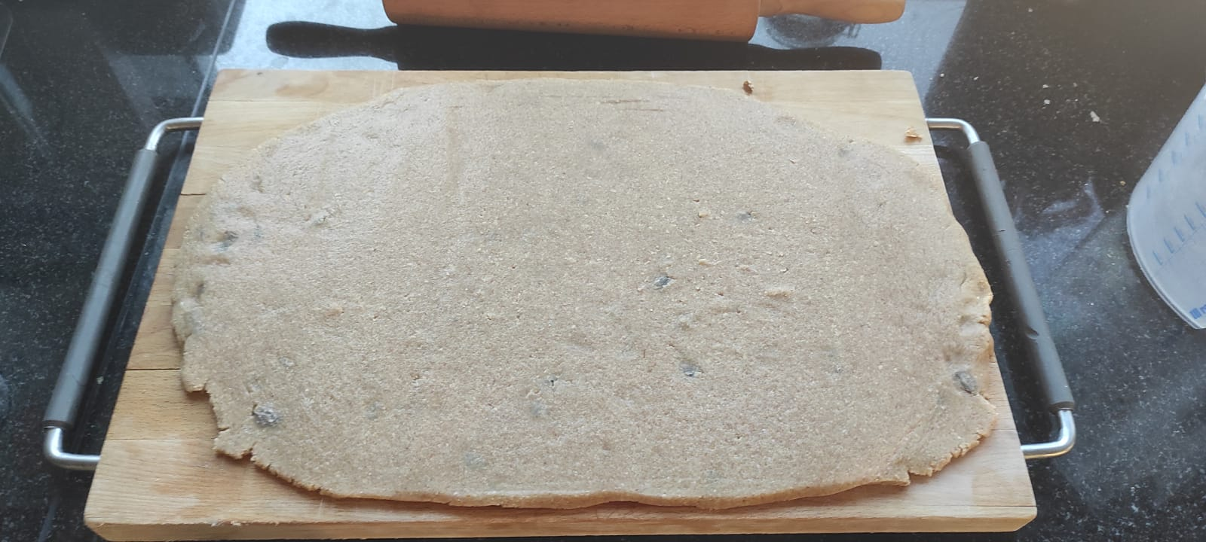

1. Get some cool cutting forms and cut the dough.

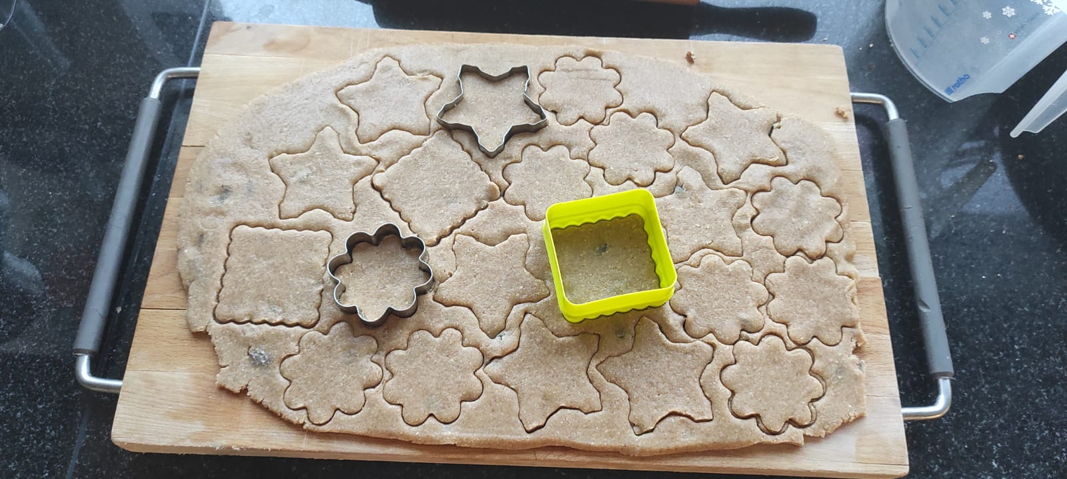

1. Put the cut shapes onto the baking plate.

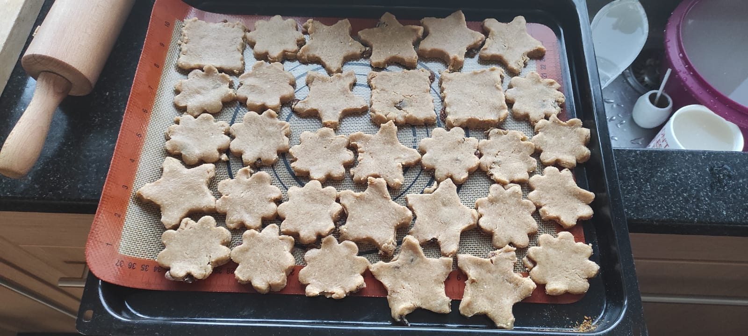

1. Bake the cookies for 25 min on 180 C°.

